COMP 9517 T1, 2020
Assignment 1: Report
Author: Bharath Naga Chandra Surampudi
ZID Z5251342

Task 1
- Slice the image into 3 parts and split the channels to (Blue,Green,Red)
- In order to handle the uneven split of image size add padding with zeros
- Calculate SSD values and SAD values for (blue, green) moving blue 20 pixels in left right top and bottom to get the offset for blue with respect to green. Align blue using obtained offset.
- Repeat step 3 for (red ,green) get the offset for red with respect to green. Align red using obtained offset.
- Merge aligned blue ,green ,aligned red to get the color image
Original Images 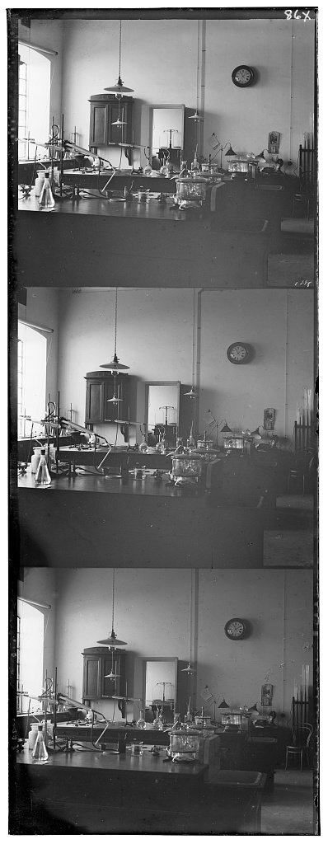 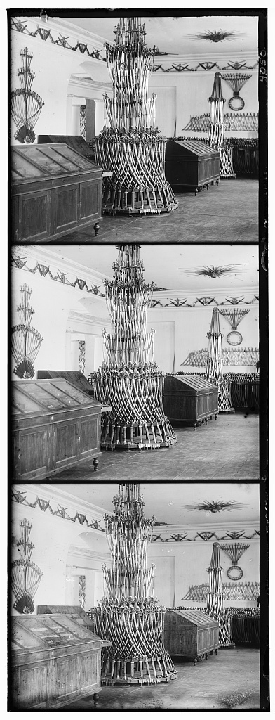
def SSD(a,b):
return np.sum((a[:,:]-b[:,:])**2)
def SAD(a,b):
return np.sum(abs(a[:,:]-b[:,:]))
After Alignment using SSD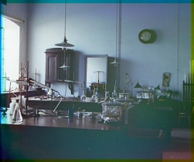 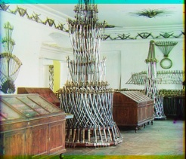
After Alignment using SAD 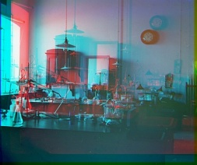 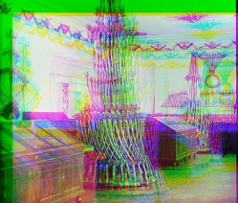

Observation:
SSD caluculates the sum of square differences between the pixels in the two channels where as SAD caluculates absolute differences between the pixels .we can see SSD alignment has better results compared to SAD even though its takes longer time to compute.

Task 2
Calculating ssd values for correct alignment in high resolution image can grow computationally large when we calculate ssd in all four directions left, right, top, and bottom .To decrease the number of computations to get the correct offset image resizing technique can be used to decrease dimensions of the image by a factor of two up to three levels from given high resolution image. Resizing beyond three levels the offset obtained will be far from the correct offset giving a bad image with RGB channels not aligned properly .Resized images placed on top of each other in the order of pixel resolution forms an image pyramid.
Original High Resolution Image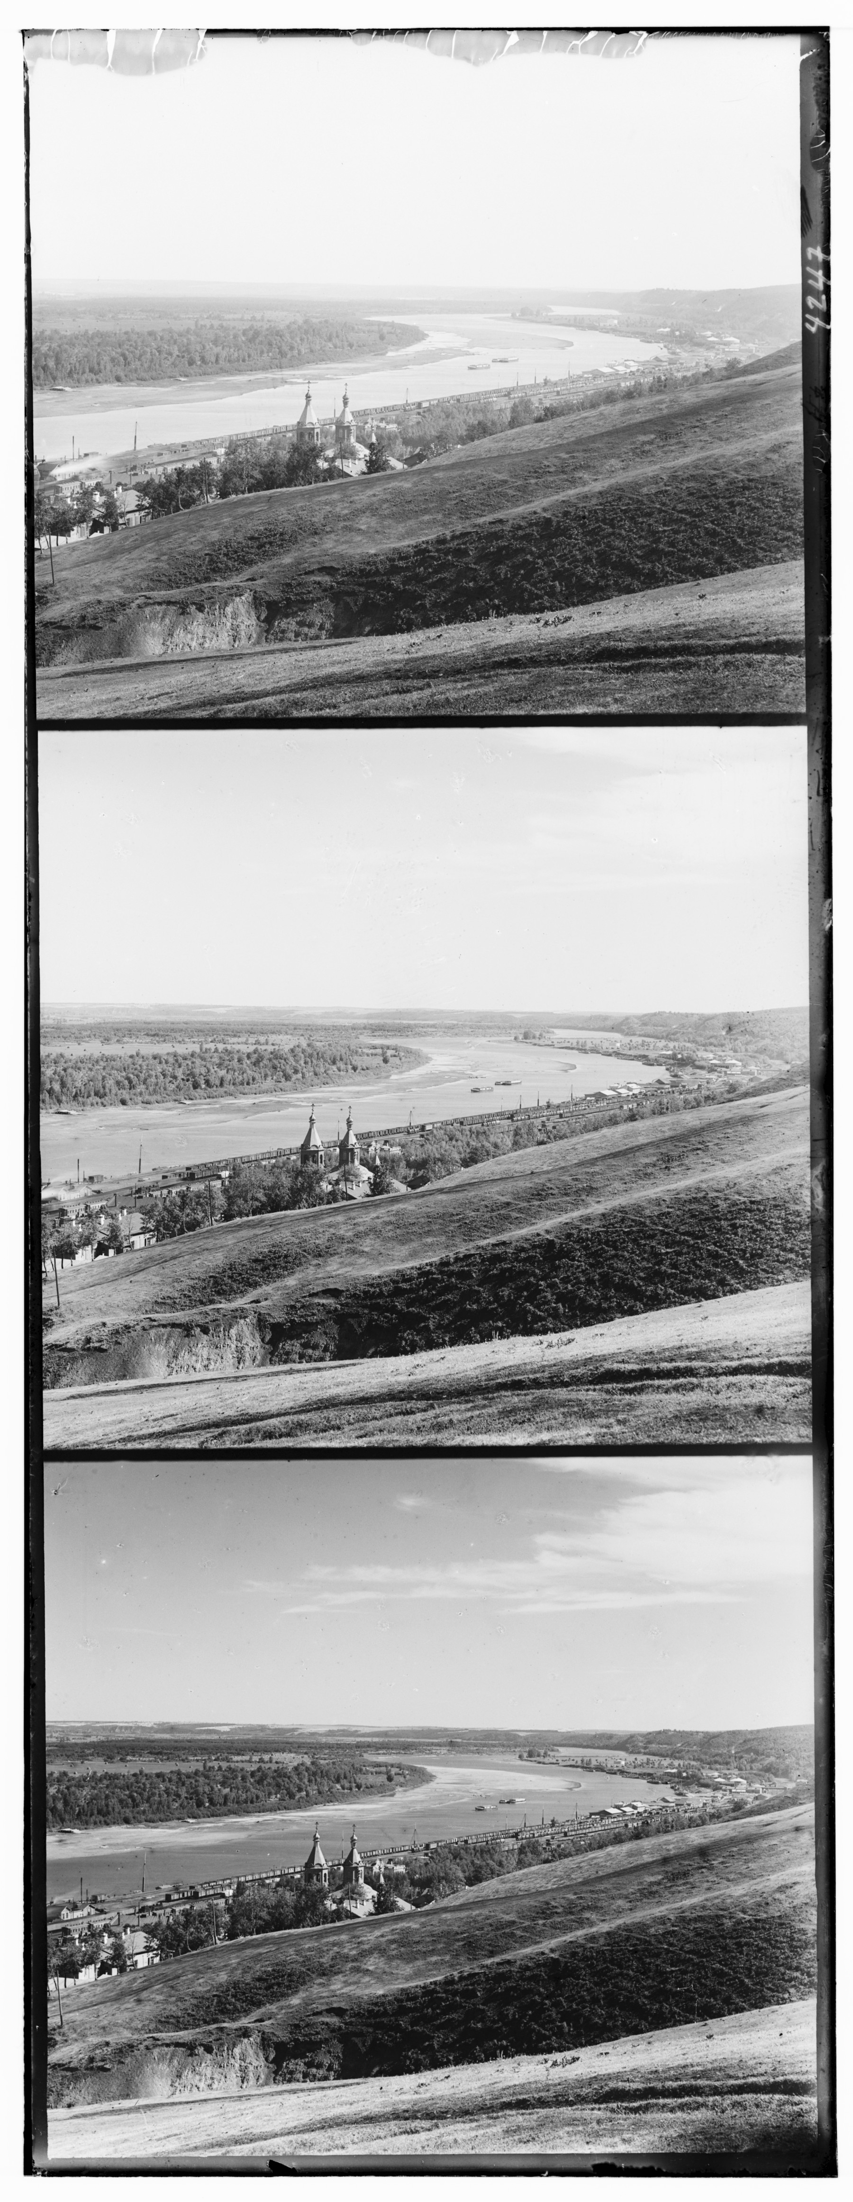
Image Pyramid resized with a factor two

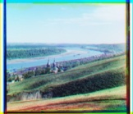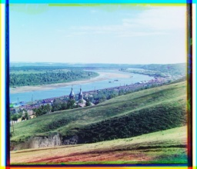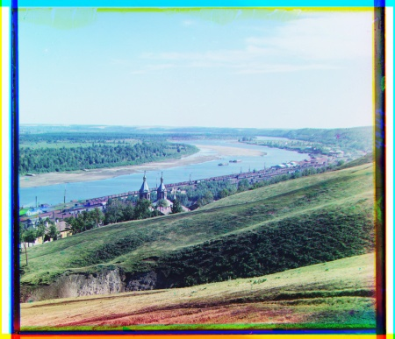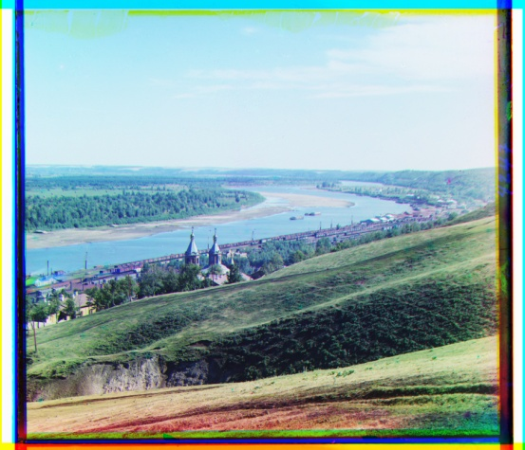

- Obtain the offsets (x,y) for the low resolution resized image in level 0 using align method in task 1.
- Using level 0 offset set a search boundary for level 1 which is in the range(-2x-1,2x+1) along x axis and (-2y-1,2y+1) along y axis .
- Calculate ssd values for level 1.Follow the same steps on the image in next level .
- Pass the new offset to the next level image and so on till reaching level 3 and merge the RGB channels to get a high resolution color image.
Observations: In task 1 the search minimal error offset is done with 20 pixels in four direction where as in task 2 that search boundary decreased to nearest neighbors of double the offset of previous level decreasing the number of calculations done in each level.

Task 3
I have done some adjustments to improve the visual quality of the image like applying guassian blur contrast stretching and border adjustments
- Applied Gaussian Blur to smoothen the image
- Applied contrast stretching to improve the contrast in an image by stretching the range of intensity values
- Removed borders from the image to improve the image visual quality
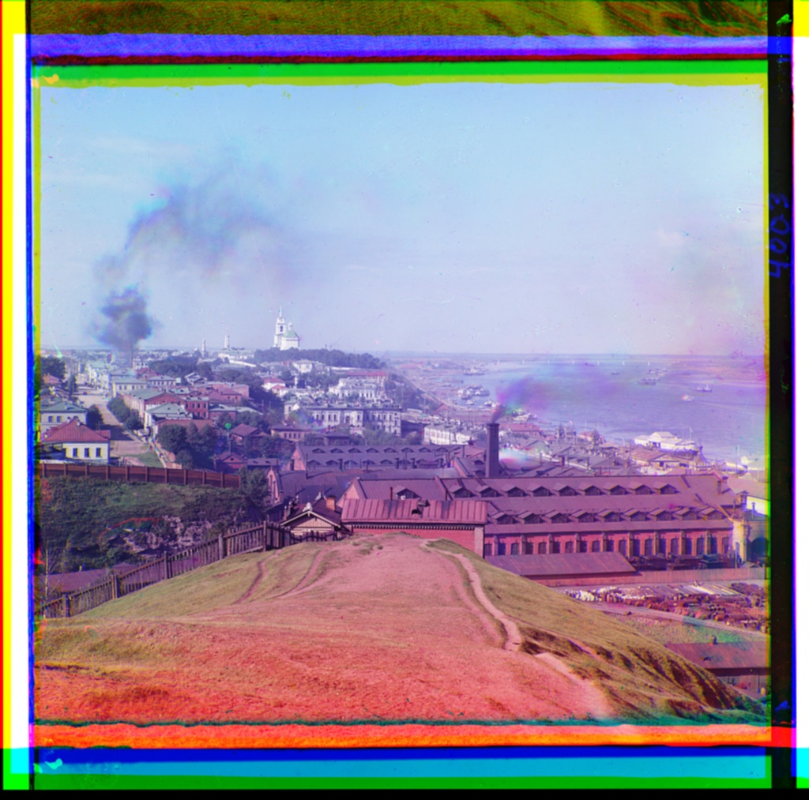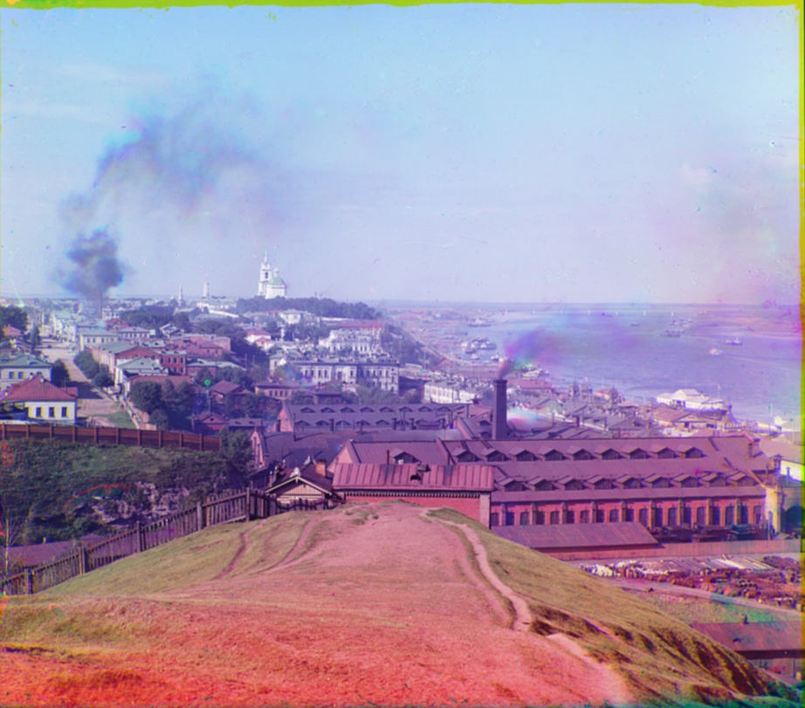
Gaussians blur Contrast Stretching Border removal

